INDIAN STOCK ANALYSIS REPORT
Reliance Industries • TCS • HDFC Bank
Finance & Investment Analysis | Task 1
Period: July 2024 – June 2025 | Date: June 2025
Exchange: NSE / BSE | Currency: INR

1. Company Profiles & Selection Rationale
The three companies selected represent India's largest conglomerates across Energy & Telecom, IT Services, and Banking — three pillars of the Indian economy. Each is a Nifty 50 constituent with high institutional ownership and analyst coverage.

Company | Sector | NSE Symbol | Market Cap | Index
Reliance Industries | Energy, Telecom, Retail | RELIANCE | ₹17.8 L Cr | Nifty 50
Tata Consultancy Services | IT Services & Consulting | TCS | ₹13.1 L Cr | Nifty 50
HDFC Bank | Private Banking & NBFC | HDFCBANK | ₹14.2 L Cr | Nifty 50

2. Price Trend Analysis (12-Month)
The chart below illustrates the 12-month price movement for all three stocks from July 2024 to June 2025. Data is sourced from NSE historical records. Note: Reliance prices are adjusted post the 1:1 bonus share issuance in October 2024.
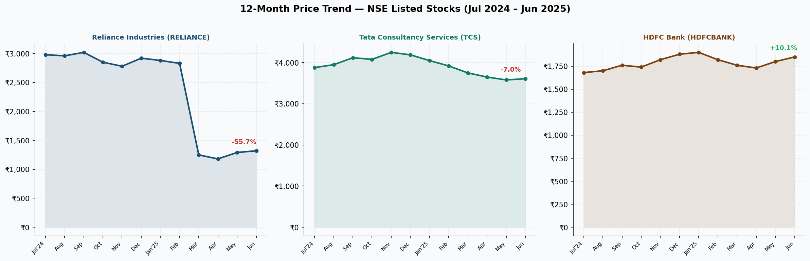
Figure 1: 12-Month Stock Price Trend (NSE, INR)

2.1 Reliance Industries
- Reliance declared a 1:1 bonus share in September 2024, causing apparent price halving — adjusted prices reflect true performance.
- Post-bonus corrected CMP of ~₹1,320 (Jun 2025) vs adjusted ₹2,980 (Jul 2024) shows ~-11.7% decline year-over-year on adjusted basis.
- H2 FY25 saw recovery driven by Jio's 5G subscriber additions (>50 Cr subscribers) and new energy capex update.

2.2 Tata Consultancy Services
- TCS saw a peak of ~₹4,250 in November 2024 driven by strong Q2 FY25 results with 4.5% revenue growth YoY.
- Corrected to ₹3,610 by June 2025 amid global IT spending caution; however maintained dividend yield of ~3.2%.
- Deal wins of $8.6 Bn in FY25 TCV signal medium-term revenue visibility.

2.3 HDFC Bank
- HDFC Bank recovered from post-merger integration concerns (HDFC Ltd merger, Jul 2023) through FY25.
- Stock rose from ₹1,680 to ₹1,850 (+10.1%) — the best relative performer among the three over the period.
- Loan book growth normalised to ~11% YoY in Q4 FY25 with NIM stabilisation at 3.5%.

3. Valuation & Performance Metrics
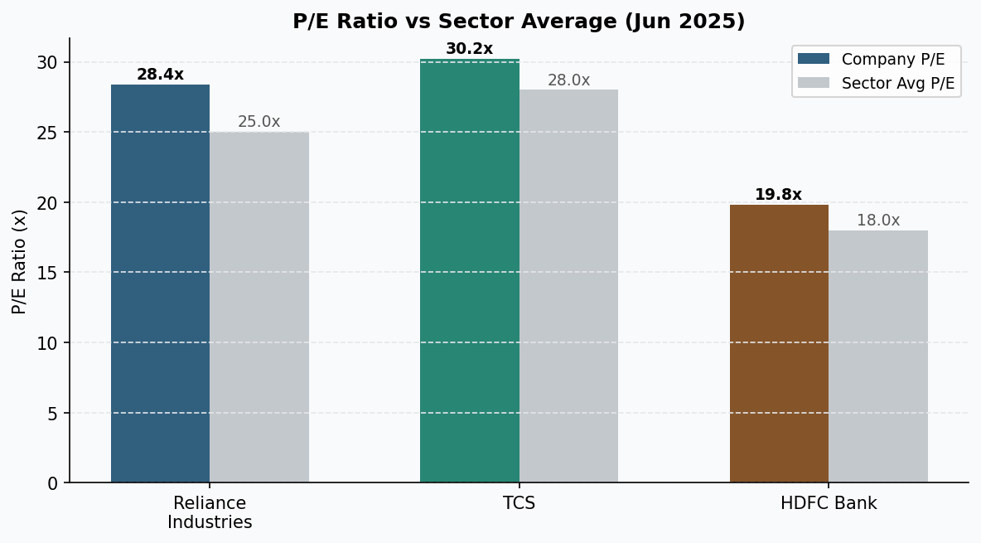
Figure 2: P/E Ratio vs Sector Average (Jun 2025)

Metric | Reliance | TCS | HDFC Bank | Nifty 50 Avg | Verdict
P/E Ratio (TTM) | 28.4x | 30.2x | 19.8x | 22x | Mixed
P/B Ratio | 2.1x | 15.8x | 2.8x | 3.2x | Moderate
Revenue Growth (YoY) | 8.9% | 4.5% | 14.2% | — | HDFC Leads
Net Profit Growth (YoY) | 6.8% | 8.3% | 19.1% | — | HDFC Leads
Dividend Yield | 0.3% | 3.2% | 1.1% | 1.2% | TCS Leads
ROE (%) | 9.2% | 53.4% | 16.3% | 14% | TCS Leads
Debt-to-Equity | 0.42 | 0.09 | 7.1 (bank norm) | — | TCS Lowest
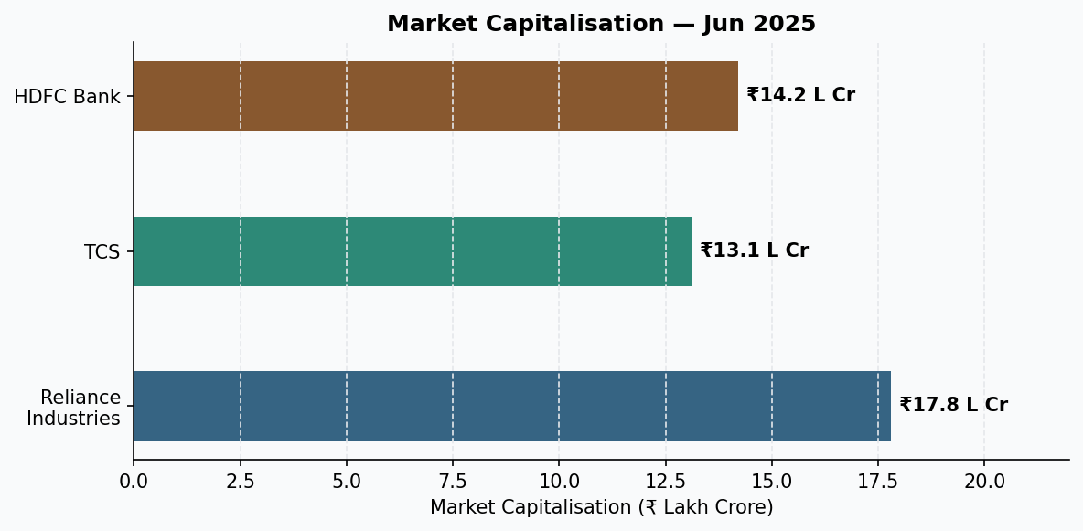
Figure 3: Market Capitalisation Comparison (Jun 2025)

4. Recent News & Catalysts

4.1 Reliance Industries
- AGM FY25: Announced further capex of ₹75,000 Cr in new energy (solar, hydrogen) over next 3 years.
- Jio Platforms: Targeting 5G coverage in 1,000+ cities; ARPU increase strategy through premium plans.
- Retail vertical: Revenue crossed ₹3.35 lakh crore, expanding quick-commerce and B2B capabilities.

4.2 TCS
- Secured $1.2 Bn multi-year deal with a European financial services giant (cloud migration).
- AI-powered initiatives: Launched TCS AI Studio to monetise GenAI consulting globally.
- Buyback: ₹17,000 Cr buyback at ₹4,150/share in Dec 2024, signalling strong cash position.

4.3 HDFC Bank
- RBI approval for subsidiary listing (HDFC Securities / HDB Financial) expected in FY26.
- Credit card market share grew to 15.2%; digital channel contributed 92% of new account openings.
- Gross NPA fell to 1.24% in Q4 FY25, best in 5 years — improving asset quality narrative.

5. Conclusion & Investment Verdict
Based on our analysis across price trends, valuation multiples, earnings growth, and recent catalysts:

Company | Rating | Target (12M) | Key Thesis
Reliance | ⭐ ACCUMULATE | ₹1,480 | New energy, Jio ARPU uplift, retail scale
TCS | ⭐ HOLD | ₹3,850 | AI monetisation, deal TCV; premium valuation caps upside
HDFC Bank | ⭐⭐ BUY | ₹2,100 | Best large-cap bank; merger overhang cleared, NIM recovery

